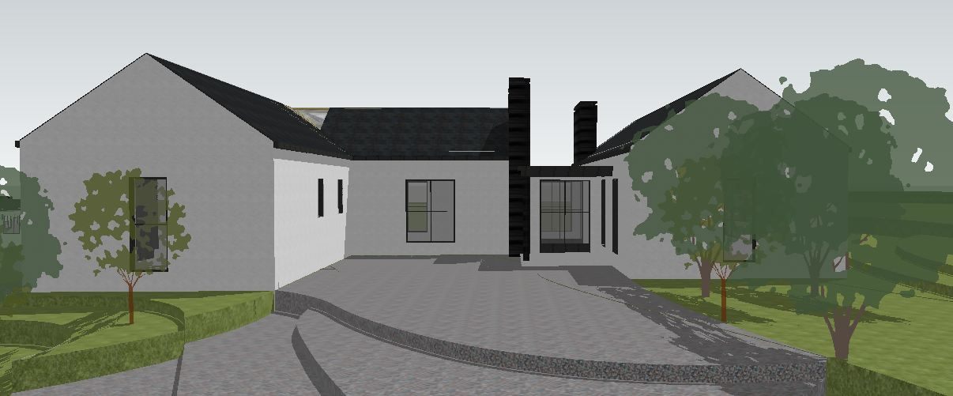
VIEW ON APPROACH

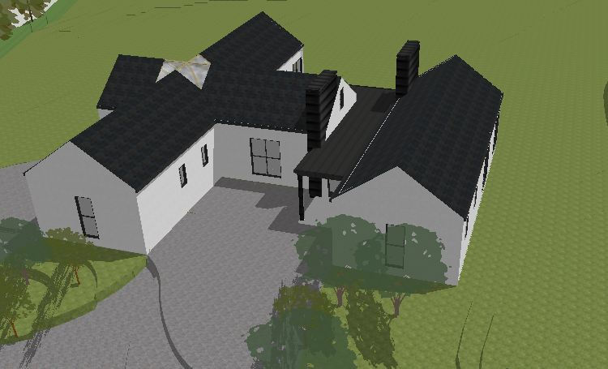
NORTH-WEST AERIAL VIEW

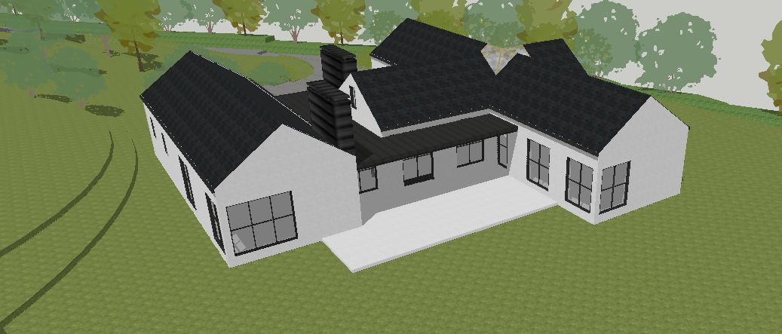
SOUTH- EAST AERIAL VIEW

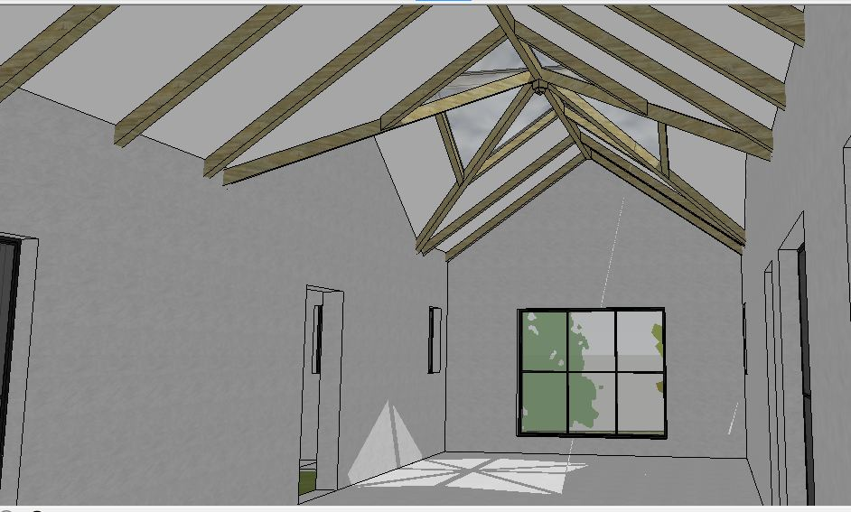
INTERIOR VIEW OF ROOF LANTERN, OVER KITCHEN/DINING/LIVING SPACE.

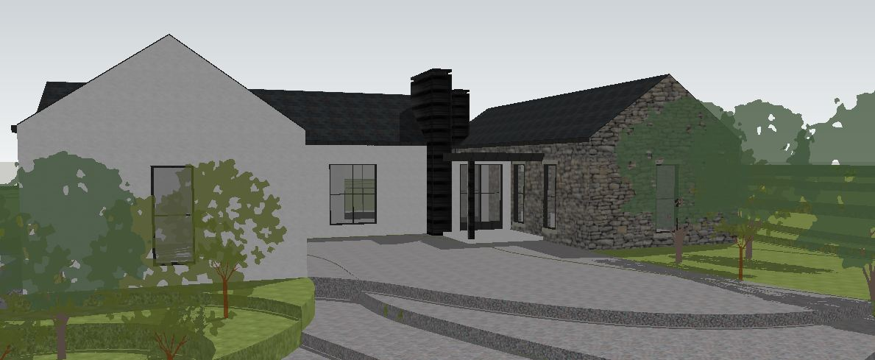
VIEW ON APPROACH-WITH STONE CLADDING.

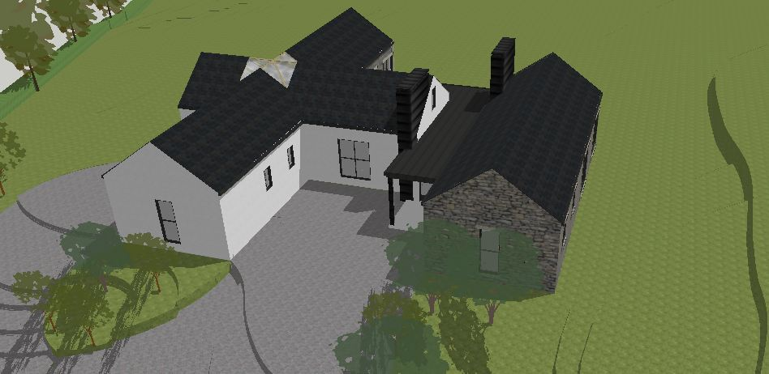 NORTH-WEST AERIAL VIEW-WITH STONE CLADDING.

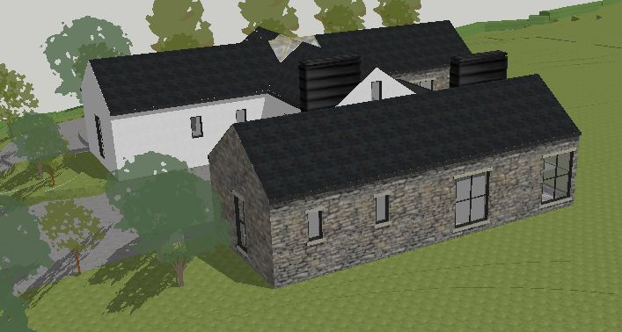
NORTH-WEST AERIAL VIEW-WITH STONE CLADDING.

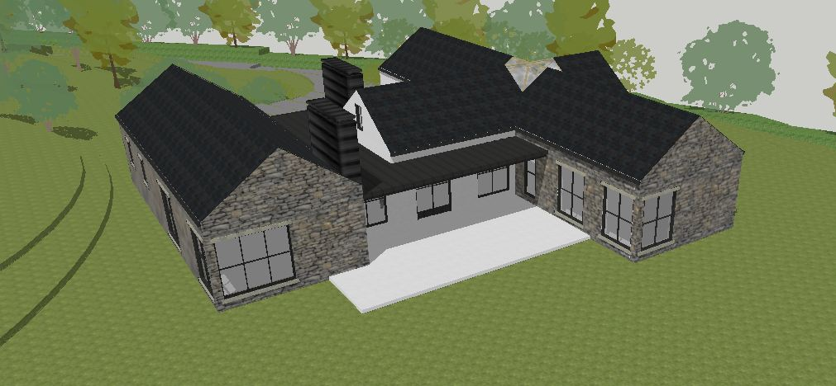
SOUTH- EAST AERIAL VIEW-WITH STONE CLADDING.

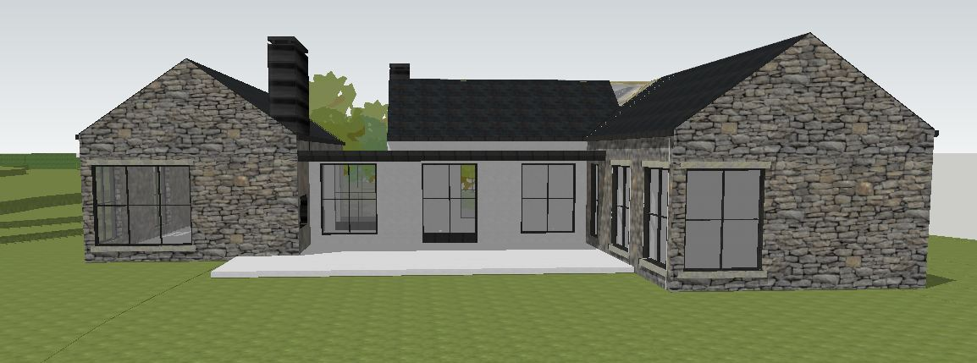
SOUTH FACING VIEW-WITH STONE CLADDING.

